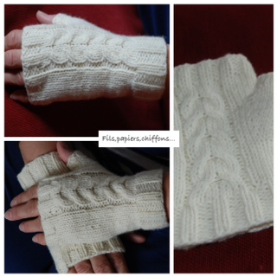
TIFFANY’S MITT

Material:

- Circular needle 6 us ( 4 mm )
- Cable needle
- Yarn DK (150 yards appr ) (I used:de rerum natura gilliat)

Cable pattern (over 8 sts)
rnds 1-5 : knit
rnd 6 : C4F , C4B

Instructions : left mitten
K: knit
P: purl
M1: make 1 stitch
C4F: slip 2 sts to cable needle and hold in front, k2, k2 from cable needle

C4B: slip 2 sts to cable needle and hold in back, k2, k2 from cable needle

CO 36 sts, close to round,
Rnd 1-10 : k2, p2
Rnd 11 - 15: ( start cable pattern) k4, p1, k8 (cable pattern ), p1, k22
Rnd 16 : k4, p 1 , rnd 6 cable pattern, p1 ,k 22
repeat rnds ( 11-16) 1 time more.

Thumb gusset
Rnd 23 : K4, p1, k 8 (cable pattern ), p1, k20, m1,k1,m1,k1
Rnd 24 : k4, p1, k 8, p1, k22

Repeat rnd 23-24 4 times more ( 11 sts )
Rnd 33 : slip 11 sts onto a piece of yarn , co 2sts over gap (37 sts )
Work 10 rnds (42 rnd)
Rnd 43:* k2, p2 * , k 2 tog (36sts)
Rnd 44 – 48 : *k2,p2 *
Bind off.

Thumb :
put 11 sts onto needle , picking 2 sts (13sts)
rnd 1-3 : k
rnd 4 : * k2, p2* , k2tog (12 m)
rnd 5-6 : * k2, p2 *
Bind off

Right mitten :
work as the left mitten but the thumb increases are worked after st19and before st 21
this pattern is for personal use only © 2013 Fils, papiers, chiffons…
Blog : http://catherineab.canalblog.com/

