Creative writing –
an acrostic on a famous love novel /on the theme of love

Have all the maidens got to mourn in stillness ?
Are all fair passions doomed to grow despised ?
Must all unsoiled verses and vows become
Loathsome and affront inuendos ?
Even, by a mad and loved hand, laughter's
Tainted ; indeed, by a loved hand happened slaughter!

A chosen scourge surely lunacy's not ;
Now I am sinking as mermaids in the
Deepest darkness of a sorrow-made stream

Oh, the morning dew gladdens this green shrine
Perhaps these colours will colour my
Heartfelt – alas too heartfelt – grief and
Even lessen those painful regrets' weight ?
Lunacy's shading my shattered senses
I am now sinking in the waves as mermaids
And my wavy grave is by flowers gladdened

Ophelia by John Everett Millais 1852

The Pre-Raphaelites were painting as Karl Marx was writing his revolutionary works in the Reading Room of the British Museum. Marx and Friedrich Engels published the Communist Manifesto in 1848, the same year the Pre-Raphaelite Brotherhood formed. The young artists who joined this radical band saw through the hypocrisy of the factory owners who bought their paintings. http://www.theguardian.com/artanddesign/2012/sep/10/preraphaelites-exhibition-victorian-sexuality-drama

Queen. There is a willow grows aslant a brook,
That shows his hoar leaves in the glassy stream. | 180
There with fantastic garlands did she come
Of crow-flowers, nettles, daisies, and long purples
That liberal shepherds give a grosser name,
But our cold maids do dead men’s fingers call them; | 184
There, on the pendent boughs her coronet weeds
Clamb’ring to hang, an envious silver broke,
When down her weedy trophies and herself
Fell in the weeping brook. Her clothes spread wide, | 188
And, mermaid-like, awhile they bore her up;
Which time she chanted snatches of old tunes,
As one incapable of her own distress,
Or like a creature native and indued | 192
Unto that element. But long it could not be
Till that her garments, heavy with their drink,
Pull’d the poor wretch from her melodious lay
To muddy death.

William Shakespeare (1564–1616).
The Tragedy of Hamlet Prince of Denmark. Act IV, scene VII
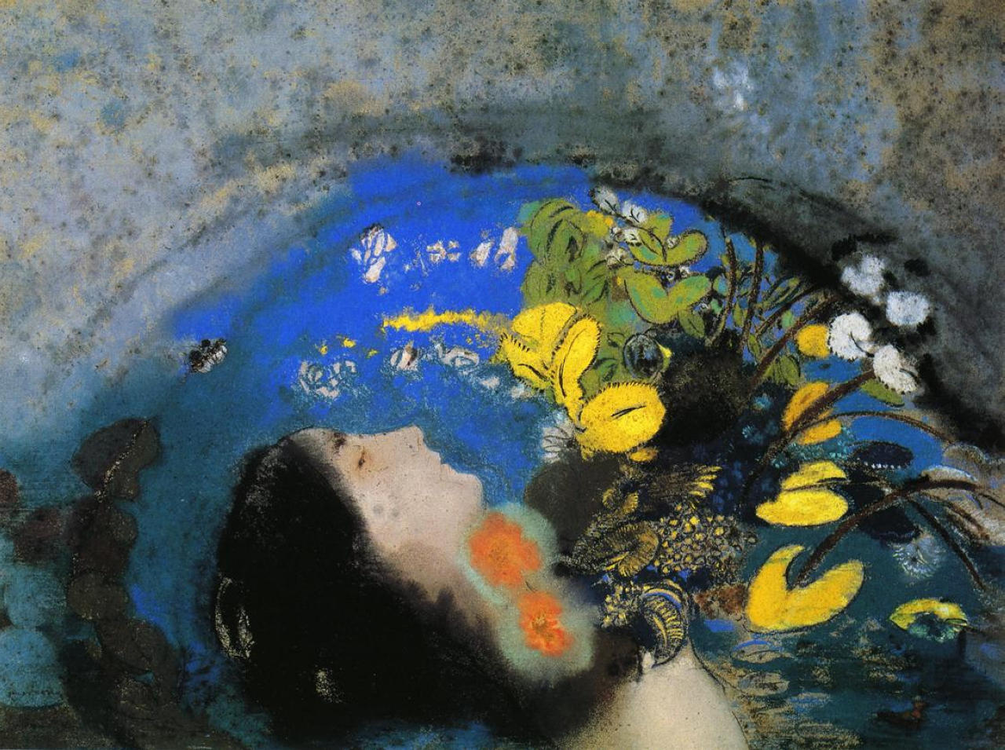

Ophélia by Odilon Redon, 1903
Lights are dancing around you
Over the senses are the feelings
Variations of your heart happen too
Every time you feel that thing
Remember that you can't just cry
Sometimes it's here and you must try

to catch it whatever it costs
but when you get it, it's lost

La Mort d'Ophélie by Delacroix, 1844

